|  |
| --- |
| Lantern hanging in night sky |
| Case Study: MCD Ramadan Campaign  Excel Analysis Report |
| |  |  |  | | --- | --- | --- | | Khola Shams | 4/9/24 | Excel Case study | |

Contents

1. Introduction 2

2. Data Cleaning, Preparation, and Analysis Steps 2

2.1. TikTok Data Cleaning Process: 2

2.2. Meta Data Cleaning Process: 4

2.3. Snapchat Data Cleaning Process: 5

3. Pivot Tables and Key Insights 7

3.1 Platform Analysis 7

3.2 Comprehensive Performance by Platform 7

3.3 Campaign-Level Performance 8

3.4 Video Completion Rate (VTR) by Market and Platform 9

3.5 Engagement, CPC, CTR, and VTR Overview 9

3.6 Audience Segmentation Analysis 10

4. Visualizations: 11

5. Macros Implementation: 11

5.1 Data Refresh Macro: 11

5.2 Performance Filter Macro: 12

5.3 Conditional Formatting Macro: 12

5.4 Formatting Summary Sheet Macro: 13

6. Conclusion: 15

7. Recommendations: 16

## Introduction

This report delves into the intricate analysis of a Ramadan digital marketing campaign that was conducted across three major platforms: TikTok, Meta, and Snapchat. The primary goal of the analysis was to assess the performance of the campaign across these platforms, uncover key insights, and offer data-driven recommendations for future campaigns. This process involved extensive data cleaning, preparation, creating complex Pivot Tables, and implementing advanced Macros to automate and streamline the analysis.

## Data Cleaning, Preparation, and Analysis Steps

The data cleaning process was cautiously structured to ensure the data was accurate, consistent, and ready for deep analysis. Below is a detailed account of the cleaning procedures for each dataset.

### 2.1. TikTok Data Cleaning Process:

**Initial Data Structure:**

* **Columns:** Sourcesheet, Market, Channel, Compaign Name, Compaign attributes, compaign id, Audience, Duration, Language , Format, Creative Variation, Amount Spent, Clicks, CPC, Paid Reach, Total Impressions, CTR, CPM,2 Second Video Views, Video Completions, VTR (2 Sec), VTR (Complete), Total Engagement, Engagement Rate
* **Issues Identified:**
  + Redundant columns with overlapping information.
  + Inconsistent data formats, especially in text fields.
  + Potential for hidden characters or anomalies in the Campaign Name column due to concatenated information.

**Step-by-Step Cleaning:**

1. **Campaign Name Decomposition:**
   * **Objective:** The Campaign Name field contained multiple pieces of information separated by underscores (_) and tilde (~). This needed to be split to isolate the different attributes.
   * **Action:**
     + Used the **Text-to-Columns** feature in Excel.
     + Specified underscore (_) and tilde (~) as delimiters to break down the Campaign Name into distinct columns: Channel Name, Channel, Objective, Audience, and Market.
     + Post-split, renamed the new columns accordingly for clarity.
   * **Outcome:** The Campaign Name column was effectively decomposed into four distinct and meaningful attributes.
2. **Redundant Column Removal:**
   * **Objective:** To eliminate unnecessary columns that either provided duplicate information or were irrelevant for analysis.
   * **Action:**
     + Removed the Ad Group Name column as the key attributes had been extracted elsewhere. The column was deemed unnecessary for the final analysis.
     + Deleted the Market column since the market data was already embedded in the decomposed Market attribute from the Campaign Name.
     + Deleted the Ad Name after extracting valuable data from it by using Text to Column feature of Excel.
   * **Outcome:** The dataset was streamlined, reducing clutter and focusing on essential data points.
3. **Text Cleaning:**
   * **Objective:** To ensure consistency and remove any potential hidden characters or irregularities in text fields.
   * **Action:**
     + Applied the **TRIM** function across text columns to eliminate leading and trailing spaces.
     + Used **CLEAN** to remove any non-printable characters that might have been introduced during data import.
   * **Outcome:** All text fields were standardized, ensuring they were free from extraneous spaces and non-printable characters.
4. **Metric Calculation:**
   * **Objective:** To clarify column meanings and introduce new metrics for a comprehensive analysis.
   * **Action:**
     + Calculated CTR (Click-Through Rate) as (Clicks / Impressions) * 100 and added it as a new column.
     + Calculated CPC (Cost Per Click) as Spend / Clicks and added it as a new column.
   * **Outcome:** The dataset was enriched with new metrics, and columns were renamed for clarity.
5. **Format Standardization:**
   * **Objective:** To standardize numeric and date formats for consistency across the dataset.
   * **Action:**
     + Reformatted all date columns to a consistent DD/MM/YYYY format.
     + Applied number formatting to Impressions, Clicks, Spend, and other metric columns to ensure uniformity (e.g., comma separators for thousands).
   * **Outcome:** The dataset’s numeric and date fields were consistent, facilitating smoother analysis.
6. **Validation:**
   * **Objective:** To verify the integrity of the cleaned data before analysis.
   * **Action:**
     + Cross-checked key metrics (e.g., Clicks vs. CTR and CPC) to ensure calculated values aligned with raw data.
     + Used conditional formatting to identify any anomalies, such as unusually high or low values that might indicate errors.
   * **Outcome:** The dataset was validated and ready for in-depth analysis.

### 2.2. Meta Data Cleaning Process:

**Initial Data Structure:**

* **Columns:** Source sheet, Market, Compaign attributes, Compaign Name, Compaign ID, Duration, Audience, Language, Format, Creative variations, Reach, Impressions, Amount spent (USD), Link clicks, CPC, 3-second video plays, Video plays at 100%, CTR(all), CTR Evaluation, all ctr evaluation, VTR, Age Group, Post engagement, total engagement, Engagement Rate 2
* **Issues Identified:**
  + The numeric attributes weren’t properly formatted. Attributes having Percentage data were also not properly Formatted. And some text based data wasn’t formatted either.

**Step-by-Step Cleaning:**

1. **Text Normalization:**
   * **Objective:** To ensure consistency in text data.
   * **Action:**
     + Converted all text data to uppercase to avoid discrepancies caused by case sensitivity.
     + Removed special characters and extra spaces using a combination of **SUBSTITUTE** and **TRIM** functions.
   * **Outcome:** The text data was standardized, ensuring consistency across all records.
2. **Data Type Validation:**
   * **Objective:** To confirm that each column contained data of the appropriate type.
   * **Action:**
     + Checked that numeric columns (e.g., Impressions, Clicks, Spend) were properly formatted as numbers.
     + Verified that the date columns followed the DD/MM/YYYY format.
   * **Outcome:** All data types were correctly assigned, reducing the risk of errors during analysis.
3. **Column Consistency Check:**
   * **Objective:** To ensure that all relevant columns had consistent and complete data.
   * **Action:**
     + Used data validation techniques to flag any missing or anomalous values.
     + Applied **COUNTIF** and **ISBLANK** functions to identify empty cells or inconsistencies.
   * **Outcome:** All columns were confirmed to have consistent and complete data, ready for further analysis.
4. **Metric Calculation:**
   * **Objective:** To clarify column meanings and introduce new metrics for a comprehensive analysis.
   * **Action:**
     + Calculated CTR (Click-Through Rate) as (Clicks / Impressions) * 100 and added it as a new column.
     + Calculated CPC (Cost Per Click) as Spend / Clicks and added it as a new column.
   * **Outcome:** The dataset was enriched with new metrics, and columns were renamed for clarity.

### 2.3. Snapchat Data Cleaning Process:

**Initial Data Structure:**

* **Columns:** Sourcesheet, Market, Channel, Compaign ID, Compaign Name, Campaign Strategy, Audience, Duration, Language, Format, Creative Variation, Amount Spent, Engagement Rate, Engagement, Clicks, CPC, CTR, Clicks Rate, Paid Reach, Total Impressions, Paid Frequency, Paid eCPM, 2 Second Video Views, Video Completions, VTR%
* **Issues Identified:**
  + Ambiguity in column names (Swipe Ups vs. Clicks), leading to potential confusion.
  + Missing columns for key metrics like CTR and CPC.

**Step-by-Step Cleaning:**

1. **Column Renaming and Metric Calculation:**
   * **Objective:** To clarify column meanings and introduce new metrics for a comprehensive analysis.
   * **Action:**
     + Renamed Swipe Ups to Clicks and Swipe Up Rate to Click Rate to align with standard industry terminology.
     + Calculated CTR (Click-Through Rate) as (Clicks / Impressions) * 100 and added it as a new column.
     + Calculated CPC (Cost Per Click) as Spend / Clicks and added it as a new column.
   * **Outcome:** The dataset was enriched with new metrics, and columns were renamed for clarity.
2. **Data Formatting:**
   * **Objective:** To ensure consistent formatting of numeric values.
   * **Action:**
     + Applied number formatting to key metric columns, ensuring values like Clicks, Impressions, Spend, and calculated metrics were displayed with appropriate decimal places and thousand separators.
   * **Outcome:** The numeric data was consistently formatted, enhancing readability and accuracy.
3. **Anomaly Detection:**
   * **Objective:** To identify and correct any potential outliers or errors in the data.
   * **Action:**
     + Used conditional formatting to highlight any values that were significantly higher or lower than expected, based on historical trends.
     + Investigated and corrected identified anomalies, ensuring the integrity of the data.
   * **Outcome:** Anomalies were identified and addressed, ensuring the dataset was robust and reliable.
4. **Column Validation and Consistency:**
   * **Objective:** To ensure that all calculated metrics were accurate and consistent across the dataset.
   * **Action:**
     + Cross-referenced calculated columns (CTR, CPC) with raw data to verify accuracy.
     + Ensured that all columns had consistent data types and no missing values.
   * **Outcome:** All calculated metrics were validated, and the dataset was consistent across all columns.

## Pivot Tables and Key Insights

### Platform Analysis

The analysis begins by examining the performance across different platforms: MetaData cleaned, Snapchat cleaned data, and TikTok cleaned Data. The following metrics were evaluated:

* **Cost Per Click (CPC)**:
  + MetaData cleaned: **120.78**
  + Snapchat cleaned data: **25.03**
  + TikTok cleaned Data: **35.23**

This indicates that the CPC for MetaData cleaned is significantly higher compared to the other two platforms, suggesting a higher cost efficiency for Snapchat and TikTok in terms of clicks.

[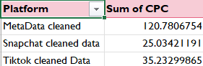](https://private-user-images.githubusercontent.com/98176045/364347246-3eb6ed68-8a40-49d8-9473-c7f00200621d.png?jwt=eyJhbGciOiJIUzI1NiIsInR5cCI6IkpXVCJ9..Bs51L5J1golUOqUysAefZv8sq0dmPmZHXOPr6D_ezBQ)

### Comprehensive Performance by Platform

A deeper analysis was conducted by aggregating the key metrics (Clicks, CPC, and Amount Spent) across the three platforms:

* **MetaData cleaned**:
  + Clicks: **419,081**
  + CPC: **120.78**
  + Amount Spent: **53,113.53 USD**
* **Snapchat cleaned data**:
  + Clicks: **54,794**
  + CPC: **25.03**
  + Amount Spent: **23,049.20 USD**
* **TikTok cleaned Data**:
  + Clicks: **79,388**
  + CPC: **35.23**
  + Amount Spent: **52,192.57 USD**

MetaData cleaned had the highest number of clicks and total spending, yet its CPC remains considerably higher. Snapchat, although having the lowest number of clicks, presents a cost-effective CPC.

[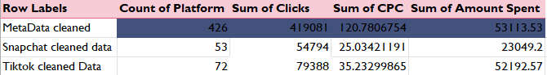](https://private-user-images.githubusercontent.com/98176045/364347352-c6ce3bd4-07b7-4047-85e9-12824321f5e3.png?jwt=eyJhbGciOiJIUzI1NiIsInR5cCI6IkpXVCJ9..6XJ7iz_WPJDYWIALSlsKJqat1nxBiK0RwI1_MvY0gsA)

### Campaign-Level Performance

The performance at the campaign level was scrutinized by evaluating Total Impressions, Clicks, and Click-Through Rate (CTR):

* **Top Campaigns by Impressions**:
  + **CN~MCDRamadan_CH ~FBIG_MK~RIY_TG**:
    - Impressions: **16,873,762**
    - Clicks: **31,766**
    - CTR: **9.41%**
  + **CN~MCDRamadan_CH ~Tiktok_MK~JED_TG**:
    - Impressions: **15,307,011**
    - Clicks: **17,744**
    - CTR: **8.82%**
* **Top Campaign by CTR**:
  + **CN~MCDRamadan_CH ~Tiktok_MK~AE_TG**:
    - CTR: **24.85%**  
      This campaign in the AE market has the highest CTR, indicating effective engagement with the target audience.

[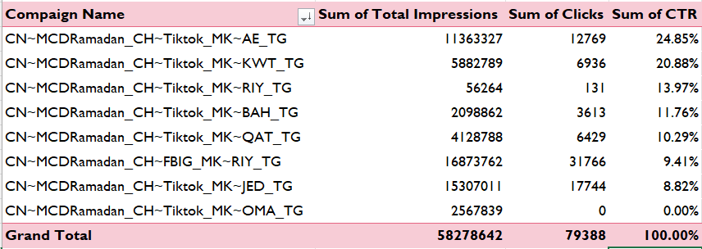](https://private-user-images.githubusercontent.com/98176045/364347431-7faf0d06-4525-4851-adb2-e455afd64f07.png?jwt=eyJhbGciOiJIUzI1NiIsInR5cCI6IkpXVCJ9..koiFbGdrEWavFGiNqr5vljuqzKEGWKTgf_qoLdRogac)

### Video Completion Rate (VTR) by Market and Platform

The analysis of Video Completion Rate (VTR) across different markets and platforms yielded the following:

* **MetaData cleaned**:
  + Highest VTR in **AE (12.79%)** and **JED (14.13%)** markets.
* **Snapchat cleaned data**:
  + High VTR in **BH (2.94%)** and **RIY (2.18%)** markets.
* **TikTok cleaned Data**:
  + Noticeable VTR in **AE (0.06%)** and **KWT (0.06%)** markets.

MetaData cleaned demonstrates superior VTR across various markets, with Snapchat performing well in certain regions like BH.

[](https://private-user-images.githubusercontent.com/98176045/364347472-cbebc256-a07b-48ed-abbd-ecff5ed79cde.png?jwt=eyJhbGciOiJIUzI1NiIsInR5cCI6IkpXVCJ9..KDM90XfH7Rku6j5fp7VCcv32INTVoL_ZZSiu23eL8Oo)

### Engagement, CPC, CTR, and VTR Overview

A consolidated analysis across MetaData cleaned, Snapchat cleaned data, and TikTok cleaned Data was conducted to evaluate Engagement Rate, CPC, CTR, and VTR:

* **MetaData cleaned**:
  + Engagement Rate: **67.97%**
  + CPC: **120.78**
  + CTR: **1.56%**
  + VTR: **61.25%**
* **Snapchat cleaned data**:
  + Engagement Rate: **0.19%**
  + CPC: **25.03**
  + CTR: **0.19%**
  + VTR: **8.34%**
* **TikTok cleaned Data**:
  + Engagement Rate: **0.31%**
  + CPC: **35.23**
  + CTR: **0.07%**
  + VTR: **0.24%**

MetaData cleaned stands out with the highest engagement rate and VTR, although with a higher CPC. Snapchat's CPC remains low but shows relatively lower engagement and VTR.

[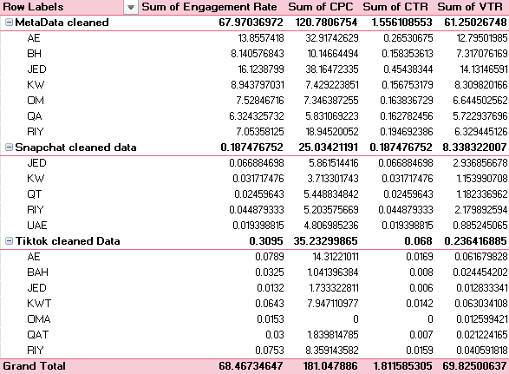](https://private-user-images.githubusercontent.com/98176045/364347563-89816923-c29a-436e-8030-38984cff9b2e.png?jwt=eyJhbGciOiJIUzI1NiIsInR5cCI6IkpXVCJ9..Tgo6Qoilt9eITK3kS3FUA-SoXaJHZBXTXb95iRiL8Mw)

### Audience Segmentation Analysis

The final part of the analysis focuses on audience segmentation, specifically comparing Boomers and Millennials in terms of Link Clicks, Impressions, Amount Spent, and Conversion Rate:

* **Boomers**:
  + Link Clicks: **87,622**
  + Impressions: **25,098,281**
  + Amount Spent: **10,950.78 USD**
  + Conversion Rate: **0.35%**
* **Millennials**:
  + Link Clicks: **331,459**
  + Impressions: **81,852,438**
  + Amount Spent: **42,162.75 USD**
  + Conversion Rate: **0.40%**

Millennials demonstrate a higher conversion rate compared to Boomers, with a significantly higher volume of impressions and clicks, indicating more effective engagement with this demographic.

[](https://private-user-images.githubusercontent.com/98176045/364347606-0203b577-bd44-4214-9509-52c065620045.png?jwt=eyJhbGciOiJIUzI1NiIsInR5cCI6IkpXVCJ9..DaLWgNnYUY4MhZ-cFzAjhOLAed47cRR841WtOO16wPY)

## Visualizations:

Following is the final Dashboard Created that includes all the visualizations created through out to better visualize, understand, and find interesting insights from the data:

[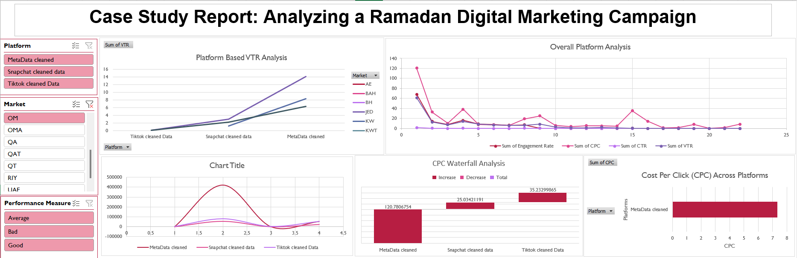](https://private-user-images.githubusercontent.com/98176045/364352096-4744db6a-8f15-41c6-b844-21231a7f3c50.png?jwt=eyJhbGciOiJIUzI1NiIsInR5cCI6IkpXVCJ9..vs3NXaUQqjMJIIB3UEizBbcvSES9caLQ8t5JOSFClmc)

## Macros Implementation:

To streamline the analysis and ensure the process could be easily replicated, I recorded and implemented several macros:

### 5.1 Data Refresh Macro:

* + **Function:** Automatically refresh all Pivot Tables with the latest data.
  + **Steps:**
    - Created a macro that refreshes all Pivot Tables across the workbook with a single click.
  + **Outcome:** Streamlined the data update process, ensuring the analysis was always based on the most current data.

[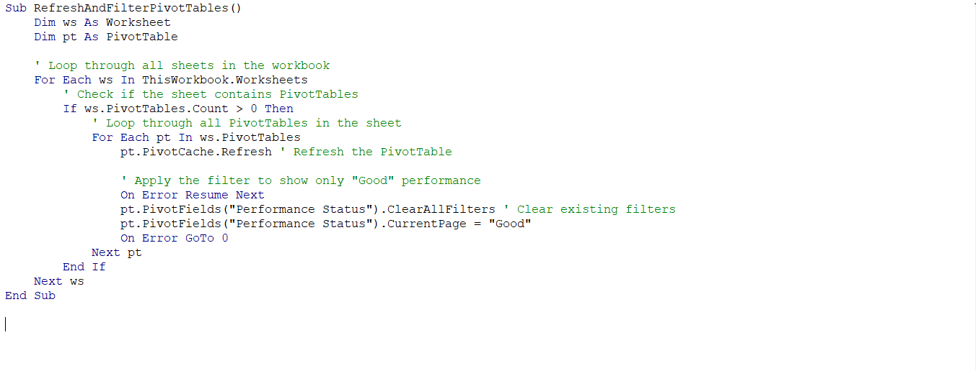](https://private-user-images.githubusercontent.com/98176045/364347704-dc5f97d8-41da-4d76-ad67-faf29b6bc1a7.png?jwt=eyJhbGciOiJIUzI1NiIsInR5cCI6IkpXVCJ9..7vIB6zljUaUhIxmOr0i6BZ6FPgI-lgA3Fe7n5e5eLKA)

### Performance Filter Macro:

* + **Function:** Filter the summary sheets to highlight campaigns with a "Good" performance status, applying a green highlight.
  + **Steps:**
    - Recorded a macro that automatically applies a filter to display only the campaigns with a "Good" performance status.
    - Implemented conditional formatting to highlight these top-performing campaigns in green.
  + **Challenges:**
    - **Filtering Issue:** Initially, the filter applied in the macro would reset whenever the data was refreshed, causing inconsistencies.
    - **Solution:** To resolve this, I added a step in the macro to reapply the filter after every data refresh, ensuring the "Good" performance campaigns remain highlighted.
  + **Outcome:** This macro streamlined the process of identifying top-performing campaigns, enabling faster, data-driven decision-making.

[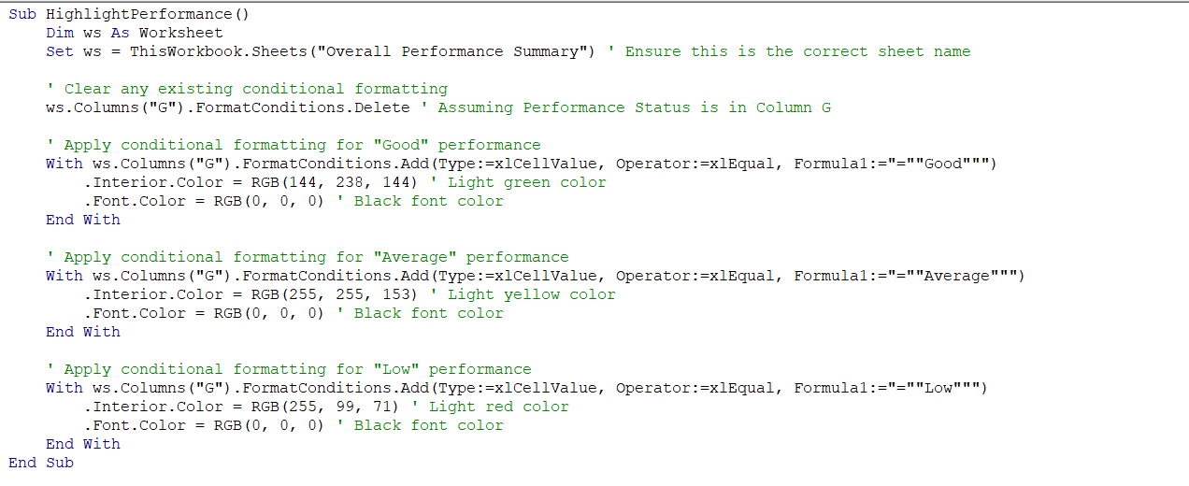](https://private-user-images.githubusercontent.com/98176045/364347744-009e88b5-c1dc-4e65-873c-b182bcfa7e67.png?jwt=eyJhbGciOiJIUzI1NiIsInR5cCI6IkpXVCJ9..KdywSqrWoeCNHpGLE-lTyCcxyK3-AjeXOss3uQlJdFw)

### 5.3 Conditional Formatting Macro:

* + **Function:** Apply conditional formatting to highlight exceptional performance metrics.
  + **Steps:**
    - Created a macro that applies conditional formatting to engagement rate columns, coloring cells based on performance thresholds.
  + **Outcome:** Automated the process of visualizing high and low performers, making insights more accessible.

[](https://private-user-images.githubusercontent.com/98176045/364347790-d74a898b-2c40-4c1b-8979-75c0009a3791.png?jwt=eyJhbGciOiJIUzI1NiIsInR5cCI6IkpXVCJ9..8G9t41LGVjfytnwcemwfwV5kRVUd9BUJTeDg3N75_h8)

### Formatting Summary Sheet Macro:

* **Function:** Enhance the "Overall Performance Summary" sheet with consistent formatting.
* **Steps:**
  + **Header Styles:** Applies bold, white text on a dark blue background, centers text, and sets the font size to 12.
  + **Column Widths:** Adjusts widths for columns A through G to fit data.
  + **Number Formatting:** Formats columns for Engagement Rate, CPC, CTR, VTR, and Performance with appropriate number formats (percentage or currency).
  + **Autofit Rows:** Adjusts row heights to fit content.
  + **Borders:** Adds thin, continuous borders around the data range and inside cells for improved readability.
* **Outcome:** Creates a visually appealing and organized summary sheet, enhancing data presentation and readability.

[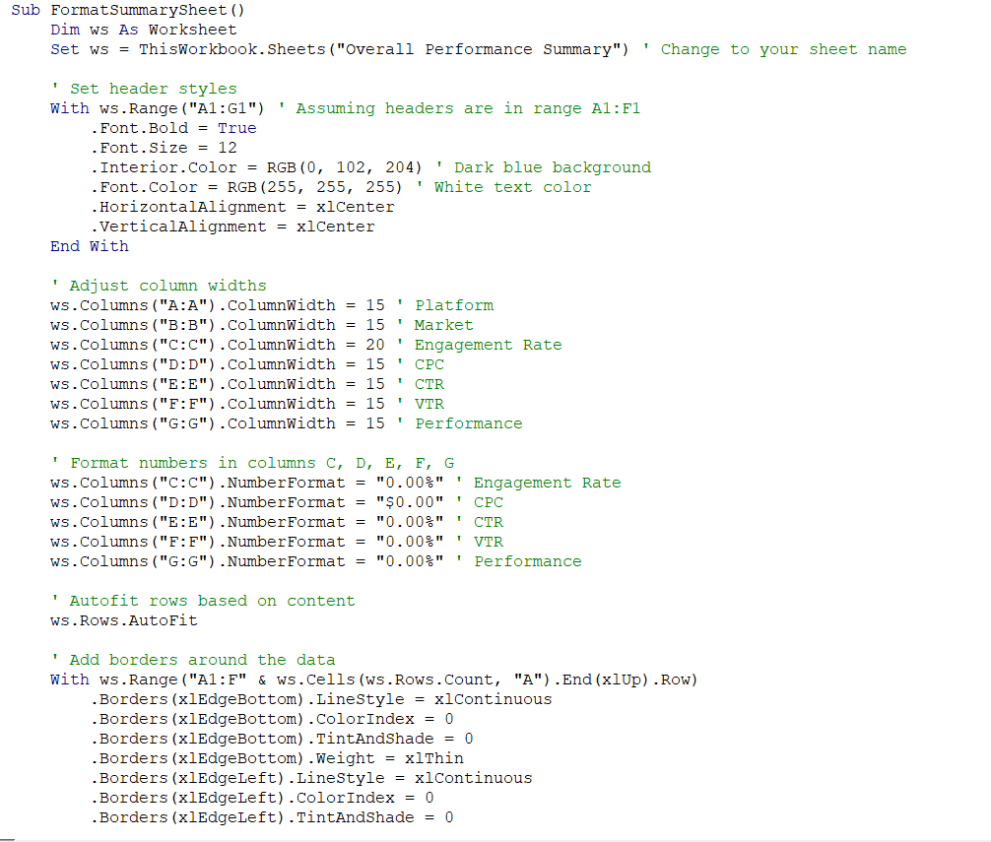](https://private-user-images.githubusercontent.com/98176045/364347902-9daadaeb-5154-4ec4-939a-b4658114b275.png?jwt=eyJhbGciOiJIUzI1NiIsInR5cCI6IkpXVCJ9..Kr1X1Tds9-AirHV0UmuVd1z7Pfgh5LeSFEJjmlcgQxk)[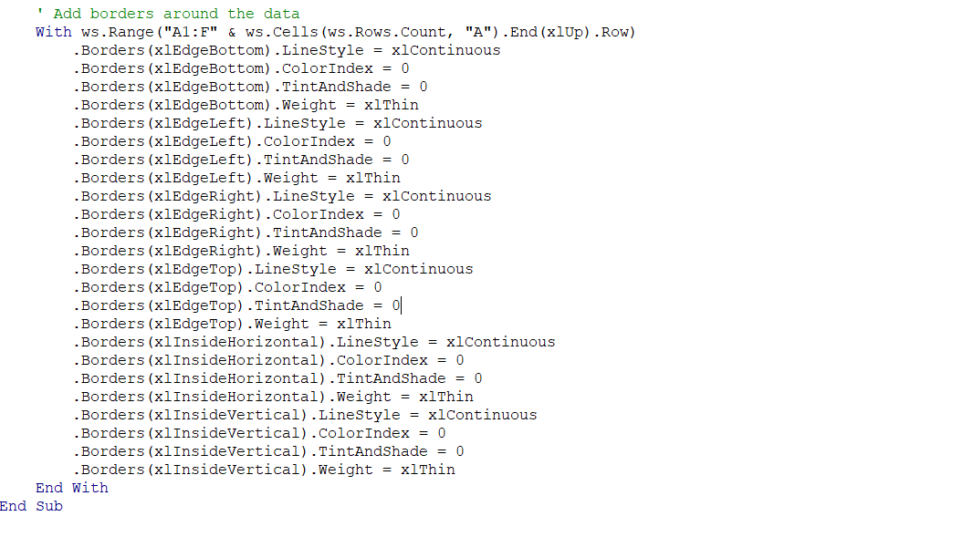](https://private-user-images.githubusercontent.com/98176045/364347947-79042187-19a7-48e2-9c47-e695d231fe64.png?jwt=eyJhbGciOiJIUzI1NiIsInR5cCI6IkpXVCJ9..78Q7C9VciVBubFzY8FDm4qOdmLIhPD-8fD_cDrFYiOs)

## Conclusion:

The detailed analysis of the Ramadan digital marketing campaign data across TikTok, Meta, and Snapchat revealed several key insights:

1. **Platform Performance:**
   * **TikTok** showed the highest engagement rates with 0.3095, indicating strong user interaction. It also had notable conversion rates and visual representation metrics, making it a strong platform for engagement-focused campaigns.
   * **Meta** demonstrated cost efficiency with a CPC of $120.78 and substantial click volumes, suggesting it provides value for money in terms of cost-per-click.
   * **Snapchat** had the lowest CPC but also relatively low engagement and conversion rates, indicating it may not be as effective for high-impact campaigns compared to TikTok and Meta.
2. **Market-Specific Insights:**
   * **AE (United Arab Emirates)** performed exceptionally well across TikTok and Meta, showing high engagement and significant total impressions. It should be a focal point for future campaigns.
   * **JED (Jeddah)** and **KW (Kuwait)** also exhibited strong performance metrics, particularly in engagement and impressions on TikTok, warranting increased focus.
3. **Demographic Trends:**
   * **Millennials** (ages 25-34) had higher click volumes and conversion rates compared to **Boomers**, suggesting that targeting this demographic could yield better results.

## Recommendations:

1. **Focus on High-Performing Markets:** Prioritize markets like AE and JED where high engagement and significant impressions were observed. Allocate more resources to these areas for future campaigns.
2. **Target Engaged Demographics:** Emphasize campaigns aimed at Millennials who showed higher engagement and conversion rates. Explore strategies to better reach Boomers and other age groups.
3. **Utilize Platform Strengths:** Leverage TikTok for engagement-driven content and Meta for cost-efficient ad placements. Consider Snapchat for supplementary, targeted efforts if budget allows.

By applying these recommendations, future campaigns can be optimized for better performance and ROI.